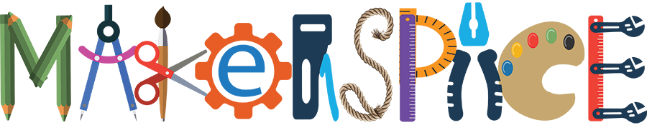Dear School Community,

We are excited to announce the beginning of a Makerspace in our school! In your students’ classes, teachers will have the opportunity to bring students to the Makerspace where they will be able to “Make”. Makerspaces promote critical thinking skills and encourage students to use design thinking to solve real-world problems. These projects can include, but are not limited to coding, engineering, sewing, animating, circuitry, and simple robotics.

We would like to ask your help by sending in any of the following materials that we could use in our school-wide maker projects. Most of the materials are recyclables, though we are also looking for reusable construction materials like Legos, Kinex, Magnatiles or blocks which you may have lying around your home that your child doesn’t use anymore.

If you are willing to donate any of the following items, please drop them off to room 115 or the school office. We will be accepting donations as long as we have specific needs. If you have any further questions or think you have something not listed that might be useful to our Makerspace, please email me at springj@bsd405.org

Thank you in advance for helping us collect these items and supporting our creative explorations!

Sincerely,
Ms. Spring, Ms. Terry and Ms. Gordon

- cereal boxes
- shoe boxes
- cardboard tubes
- plastic lids/caps
- playing cards
- egg cartons
- bubble wrap
- wine corks
- used electric toothbrushes
- broken flashlights
- magnets
- old craft supplies
  - fabric
  - buttons
  - beads
  - yarn
  - thread
  - string
  - pillow stuffing
  - popsicle sticks
- Legos

- Kinex
- Magnatiles
- Blocks

